**Les clubs du lycée Saint Léon**

**WEB RADIO** **INFORMATIQUE**

**ECHECS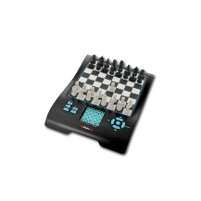 THEATRE**[](https://www.google.fr/url?sa=i&rct=j&q=&esrc=s&source=images&cd=&cad=rja&uact=8&ved=2ahUKEwj10LOem_vdAhVFz4UKHSdbATcQjRx6BAgBEAU&url=https://actu.fr/pays-de-la-loire/clisson_44043/au-theatre-ce-week-end-2_9032160.html&psig=AOvVaw08zjNa-p0oUhgVUpAXLXPV&ust=1539238185151301)

**JEUX DE PLATEAUX 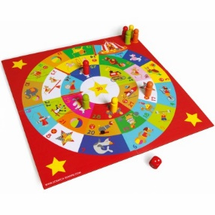 MUSIQUE CAFE THEO** [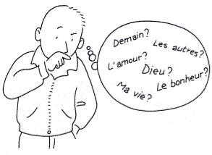](http://www.google.fr/url?sa=i&rct=j&q=&esrc=s&source=images&cd=&cad=rja&uact=8&ved=2ahUKEwjDq5GShPzdAhXJxIUKHbTWBfkQjRx6BAgBEAU&url=http://aumoneriedebrignoles.over-blog.com/pages/Petit_lexique_sur_laumonerie_a_lusage_des_parents-3712890.html&psig=AOvVaw3MXiQ4MB2pQ7DO6jrlczWD&ust=1539266338682174) **CINEMA** 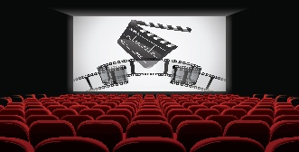

**ATELIER PRESSE** [](http://www.google.fr/url?sa=i&rct=j&q=&esrc=s&source=images&cd=&cad=rja&uact=8&ved=2ahUKEwiWxvnNpPvdAhWqzIUKHRfeB_0QjRx6BAgBEAU&url=http://smellslikerock.net/revue-de-presse/&psig=AOvVaw19qWDPfdfIUR70j1ZN9Y_3&ust=1539240699016036) **ASTRO ESPACE** [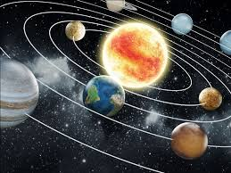](https://www.google.fr/url?sa=i&rct=j&q=&esrc=s&source=images&cd=&cad=rja&uact=8&ved=2ahUKEwiQ14X1oPvdAhUOx4UKHQmfADwQjRx6BAgBEAU&url=https://www.vodeo.be/comment-bien-choisir-votre-materiel-dastronomie/&psig=AOvVaw3Mp1yJXoIyw-ZMOqEseL6y&ust=1539239661911858)